**Prepared for:**

**Centers for Medicare & Medicaid Services and Office of the National Coordinator for Health Information Technology**

**CMS Alliance to Modernize Healthcare  
Federally Funded Research and Development Center**

Technical Authority for the Unified Clinical Quality Improvement Framework

Bonnie User Guide

Version 1.6

January 4, 2017

The views, opinions, and/or findings contained in this report are those of The MITRE Corporation and should not be construed as official government position, policy, or decision unless so designated by other documentation.

© 2016, The MITRE Corporation. All Rights Reserved. Approved for Public Release. Distribution Unlimited 13-4297.

Record of Changes

| Version | Date | Author / Owner | Description of Change |
| --- | --- | --- | --- |
| 0.1 | April 15, 2014 | Andre Quina / MITRE | Initial draft |
| 0.1.1 | July 18, 2014 | Cristen Jones / MITRE | Update for Bonnie v 1.1 |
| 0.2 | April 13, 2015 | Cristen Jones / MITRE | Update for Bonnie v 1.3 |
| 1.4 | January 13, 2016 | Pace Ricciardelli / MITRE | Update for Bonnie v 1.4 |
| 1.5 | November 18, 2016 | David Connolly and Lizzie DeYoung / MITRE | Update for Bonnie v 1.5 |
| 1.6 | January 4, 2017 | Kristian Mulcahy and Chris Tohline / MITRE | Update for Bonnie v 1.6 |
|  |  |  |  |
|  |  |  |  |
|  |  |  |  |
|  |  |  |  |
|  |  |  |  |

Table of Contents

1. Introduction 1

1.1 Background 1

1.2 Purpose 1

1.3 Application Description 1

2. User Account Creation 3

2.1 Login Page 3

2.2 Creating a New User 3

2.3 Resetting a Password 4

2.4 Account Management 5

3. Measure Dashboard 6

3.1 Overview 6

3.2 Loading a New Measure 7

3.3 Updating a Measure 10

3.4 Creating Synthetic Test Records 10

4. Measure Results View 12

4.1 Overview 12

4.2 Measure Logic 14

4.3 Creating a New Test Record 14

4.4 Calculation Results 15

4.5 Editing a Test Record 17

4.6 Cloning a Test Record 17

4.7 Deleting a Test Record 18

4.8 Sharing a Test Record 18

4.9 Updating a Measure 18

4.10 Deleting a Measure 19

5. Building a Patient Test Record 20

5.1 Overview 20

5.2 Building a Synthetic Patient 21

5.3 Building the Patient History 22

5.3.1 Patient History Items that Fulfill Past Items 24

5.3.2 Representing a Cumulative Medication Duration 24

5.4 Incremental Calculation 25

5.5 Outdated Code Sets 26

6. Measure History 27

6.1 Overview 27

6.1.1 Viewing Changes to the Logic of the Measure 28

6.2 Patient Compare View 28

7. Patient Dashboard 30

7.1 Overview 30

7.2 Adding and Editing Patients 32

8. CQL Learning Tool 34

8.1 Overview 34

9. Importing Patients from the Patient Bank 37

9.1 Overview 37

9.2 Filtering Patient Results 39

9.3 Using Test Patients 39

10. Additional Tools 42

10.1 Complexity and Change Dashboard 42

11. Feedback and Support 45

12. Frequently Asked Questions 46

Acronyms 48

List of Figures

Figure 1. Bonnie Login Page 3

Figure 2. Account Registration Page 4

Figure 3. Password Reset Page 4

Figure 4. Account Management Page 5

Figure 5. Measure Dashboard View 6

Figure 6. New Measure Dialog – MAT Package 8

Figure 7. New Measure Dialog – XML File 9

Figure 8. Finalize Measure Dialog 9

Figure 9. Updating Measure Dialog 10

Figure 10. Measure View 13

Figure 11. Measure Data Criteria and Supplemental Data Elements 14

Figure 12. Expanded Results View 15

Figure 13. Logic Calculation Highlight – Passing Results 16

Figure 14. Logic Calculation Highlight – Failing Results 17

Figure 15. Measure Upload Summary Popup 18

Figure 16. Patient Builder View 20

Figure 17. Continuous Variable Measures Expected Populations 22

Figure 18. Building Patient History, including Edit Clinical Element View 23

Figure 19. References Section of the Patient History Builder 24

Figure 20. Editing a Medication 25

Figure 21. Error Message for Outdated Patient Codes 26

Figure 22. Measure Upload History View 27

Figure 23. Logic Changes from an Updated Measure 28

Figure 24. Patient Compare View 29

Figure 25. Patient Dashboard View 31

Figure 26. Patient Dashboard Logic 32

Figure 27. Patient Dashboard Options 32

Figure 28. Patient Dashboard Inline Edit 32

Figure 29. Navigating to the CQL Learning Tool 34

Figure 30. CQL Learning Tool 35

Figure 31. CQL Learning Tool after Evaluation 36

Figure 32. Patient Bank View 38

Figure 33. Patient Listing Example 38

Figure 34. Example Filter Usage 39

Figure 35. Patient Result Details 40

Figure 36. Selected Patients 40

Figure 37. Selecting Sets of Measures to Compare 42

Figure 38. Complexity Graph 42

Figure 39. Complexity Grid 43

Figure 40. Measure Complexity Change Details 43

Figure 41. Measure Difference Sorted by Size 44

Figure 42. User Group Link on Bonnie Splash Page 45

Figure 43. User Group Link in the Application Header 45

# Introduction

## Background

Bonnie is a software tool that allows Meaningful Use (MU) electronic Clinical Quality Measure (eCQM) developers to test and verify the behavior of their CQM logic. The main goal of the Bonnie application is to reduce the number of defects in eCQMs by providing a robust and automated testing framework. The Bonnie application allows measure developers to independently load measures that they have constructed using the Measure Authoring Tool (MAT). Loading the measures into Bonnie converts the measures from their Extensible Markup Language (XML) eSpecifications into executable artifacts and measure metadata. Developers can then use the measure metadata to build a synthetic patient test deck for the measure from the clinical elements defined during the measure construction process. By using measure metadata as a basis for building synthetic patients, developers can quickly and efficiently create a test deck for a measure. The Bonnie application helps measure developers execute the measure logic against the constructed patient test deck and evaluate whether the logic aligns with the intent of the measure.

Bonnie has been designed to integrate with the nationally recognized data standards the Meaningful Use program uses for expressing CQM logic for machine-to-machine interoperability. This integration provides enormous value to the eCQM program and federal policy leaders and stakeholders. The Bonnie tool verifies that the new and evolving standards for the Meaningful Use eCQM program are flexible and can be implemented in software.

Bonnie was also designed to provide an intuitive and easy-to-use interface based on feedback from the broader measure developer community. A key goal of the Bonnie application is to deliver a user experience that provides an efficient and intuitive method for constructing synthetic patient records for testing and validating eCQMs.

Finally, the Bonnie software is freely available via an Apache 2.0 open source license. The Meaningful Use program makes all or parts of the Bonnie software available for inspection, verification, and even reuse by other government programs or federal contractors.

## Purpose

The purpose of this document is to describe the functionality of the Bonnie web application that allows measure developers to test and verify the behavior of their CQM logic. This document provides Bonnie users with step-by-step instructions for testing eCQMs by building synthetic patient records.

## Application Description

The Bonnie application provides the capability to import measures defined in Health Quality Measure Format (HQMF) XML. The HQMF specification provides the metadata and logic that describe the specifics of calculating a CQM. The Bonnie application can load the HQMF describing a measure and programmatically convert the HQMF specification into an executable format that allows calculation of the measure directly from the specification.

The Centers for Medicare & Medicaid Services (CMS) Measure Authoring Tool is the primary source for HQMF documents used by the Bonnie application. Measure developers use the MAT to build eCQMs and export those measures as measure bundles containing both the HQMF and value sets used as part of the calculation. These measure bundles can be downloaded from the MAT and loaded into the Bonnie user interface for measure testing.

Once an eCQM has been loaded into the Bonnie application, a user can inspect the measure logic and then build synthetic test records and set expectations on how those test records will calculate against a measure. This capability to build synthetic test patient records, set expectations against those records, and calculate the measures using those patient records provides an automated and efficient testing framework for eCQMs. Through the Bonnie-supported eCQM testing framework, measure developers can more clearly understand the behavior of the measure logic and validate that the measure logic encodes their intent, as well as validate multiple iterations of measure updates against a test deck.

In addition, the development of a test deck as part of measure development provides benefits after the measures are finalized. For example, the test deck can demonstrate the intent of the measure through the patient examples in the deck. The systems in the test deck implement those measures with a means to validate their development through a base set of synthetic patient records with known expectations for calculating against the implemented measures. Finally, the test deck can provide input for the Meaningful Use certification program. If the synthetic patients are clinically valid, Cypress users can use them in addition to or instead of their own patients.

# User Account Creation

## Login Page

Users require a valid account to access the Bonnie application. All measures loaded into the Bonnie application and all synthetic test patients are isolated by account. Therefore, users can only view, access, and modify data that they have loaded under their own account. shows the login screen for the Bonnie application. To log in, a user must provide the email address and password for a valid account.



Figure . Bonnie Login Page

## Creating a New User

A user can create a new account by clicking the “register” link on the login page. The register link brings the user to account creation page shown in . A user can create a new account by filling out the fields in the registration form and clicking the “REGISTER” button. Once an account has been created, the user can log in to the Bonnie application with the email address and password specified as part of account creation.



Figure . Account Registration Page

## Resetting a Password

If a user forgets a password or an account is locked, the user can reset the password using the password reset page shown in Figure 3. This page is accessed from the “forgot password?” link on the login page (Figure 1). On the password reset page, the user provides the email address associated with the account and then presses the “Send” button. This action sends an email to the registered email address for the account to facilitate resetting the user’s account password.



Figure . Password Reset Page

## Account Management

After logging into the application, the user can change the information associated with the account by accessing the account management page shown in Figure 4. The account management page can be opened by clicking the “Account” link in the application header shown at the top of . From this page, users can change the information provided during the registration process and select a new password for their account.

The header of the Account Management page has three links for Dashboard, Help, and Logout. The page presents fields for Account Information, including entering first and last name, email address, phone number, and password.  At the bottom right are two buttons, "cancel" and "save", as well as a link that to "Delete your account."


Figure . Account Management Page

# Measure Dashboard

## Overview

The Measure Dashboard page, as shown in , is the initial page presented to users when they log into the application. The Measure Dashboard shows the calculation status of each measure loaded into the system. The calculation status shows how many patient records have been built for the measure, whether the measure is currently passing or failing, and how many patients are passing or failing for each measure.

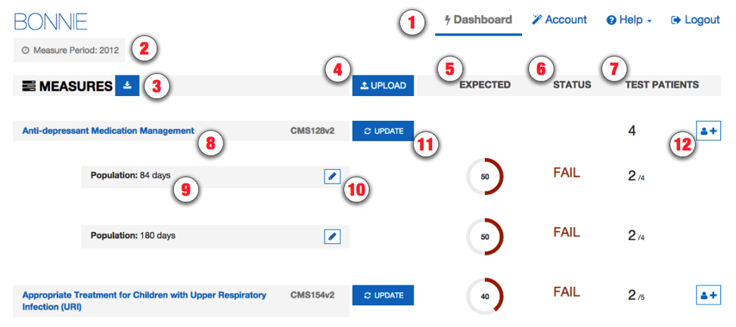

Figure . Measure Dashboard View

The Measure Dashboard View employs the following user interface (UI) elements (indicated by their item numbers in ):

1. Header – Allows the user to navigate to different parts of the application, access account information, send a support email (Contact), and log out of the application.
2. Measure Period Date – Displays the measurement period used for calculating measures.
3. Measures Download Button – Allows the user to download a bundle containing all of their measures.
4. Upload Button – Allows the user to upload a new measure.
5. Expected Column – Displays the percentage of passing patients for the measure.
6. Status Column – Displays the current status of the measure (New, Pass, Fail)
7. Test Patient Column – Displays the number of patients passing out of the total number of patients.
8. Measure Title – Displays the title for the measure and allows navigation to the measure view.
9. Subpopulation and stratification titles – Displays the titles for subpopulations or stratifications of a measure.
10. Edit Title Button – Allows the user to rename a subpopulation or stratification.
11. Update Button – Allows the user to update a previously loaded measure.
12. Add Patient Button – Allows the user to start building a new patient for a measure.

## Loading a New Measure

When a user logs into the system for the first time, there will be no measures associated with the account. The user’s first step is to load a measure into the account to begin testing the measure with the Bonnie application. The New Measure dialog, as shown in Figure 6, prompts the user to upload a measure.

The user may either upload a measure at this time or close this display and upload a measure later. After one or more measures has been uploaded, this page displays the current set of measures the user has loaded into the system along with the subpopulations and stratifications associated with the measures. The Measure Dashboard allows users to navigate to the details of individual measures, upload a new measure, or update the definition of an existing measure.

There are two ways that a measure can be loaded into Bonnie. The first is to load the entire MAT package if it contains an Excel spreadsheet of value sets. If the user loads a package this way, the value sets contained in the Excel spreadsheet are what will be used in Bonnie; however, these value sets may be out of date with the value sets on the Value Set Authority Center (VSAC) website. The second way to load a measure is to unzip the MAT package and to load the XML file entitled with the CMS ID and version.

The steps for loading a new measure as an entire MAT package are as follows:

1. Click the “Upload” button (item #4 in Figure 5) on the Measure Dashboard, which opens the New Measure Dialog shown in Figure 6.
2. On the New Measure Dialog:
3. Choose a MAT export zip file.
4. Specify if the measure is eligible professional (EP) or eligible hospital (EH).
5. Specify if the measure is Patient-based or Episode of Care.
6. Click the “Load” button.

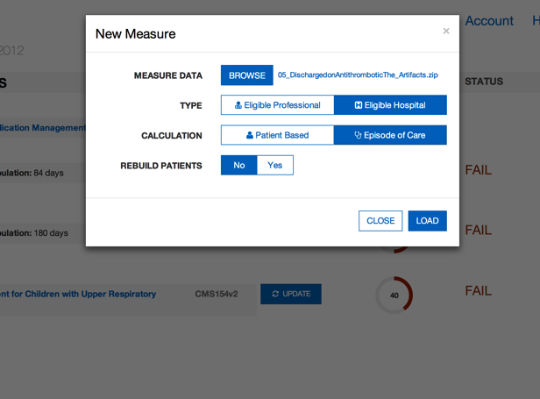

Figure . New Measure Dialog – MAT Package

The steps for loading a new measure as an XML file are as follows:

1. Click the “Upload” button (item #4 in Figure 5) on the Measure Dashboard, which opens the New Measure Dialog shown in Figure 7.
2. On the New Measure Dialog:
   1. Choose a measure XML file from a MAT package.

(1) The New Measure dialog will show VSAC Username and VSAC Password fields.

* 1. Enter your VSAC credentials.

(1) If you do not already have VSAC credentials, click the link that says “Register for VSAC”, which will take you to the UMLS Terminology Services page to register for a UMLS License. The credentials entered here will serve as your VSAC credentials.

* 1. Specify if the measure is eligible professional (EP) or eligible hospital (EH).
  2. Specify if the measure is Patient-based or Episode of Care.
  3. Click the “Load” button.

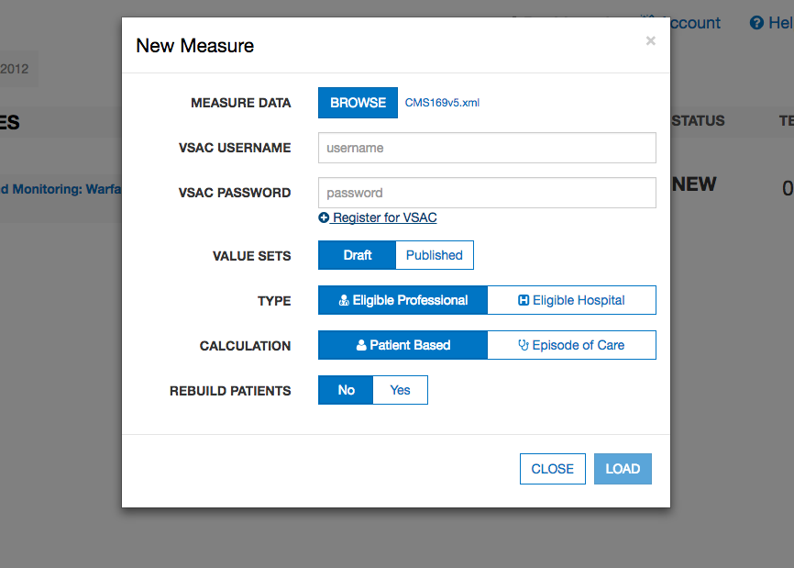

Figure . New Measure Dialog – XML File

The action of clicking the “Load” button in the New Measure Dialog uploads the measure to the application for processing. If the measure loaded is Episode of Care or has multiple populations, the user is presented with the Finalize Measure Dialog shown in . This dialog allows the user to specify the episode(s) of care for the measure and provide titles for subpopulations. Once the Finalize Measure fields have been filled out, the user clicks the “Done” button to finish loading the measure. Once measure loading is complete, the application directs the user to the Measure Dashboard (Figure 5) with the new measure available. If the measure is not Episode of Care or does not have subpopulations, the user will not be presented with the Finalize Measure Dialog because no additional information is required to load the measure.

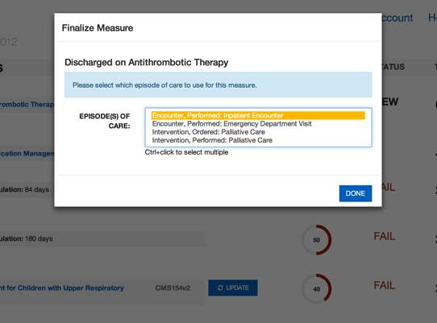

Figure . Finalize Measure Dialog

## Updating a Measure

Once the measure has been loaded, the testing process may identify issues with the measure. When issues are identified, the logic must be updated in the MAT to resolve these issues. Alternatively, the measure could be updated in the MAT as part of an annual update. Once a measure has been updated in the MAT, it may be necessary to update that measure in Bonnie for testing. To update a measure, follow these steps:

1. Click the “Update” button (item #11 in Figure 5) on the Measure Dashboard, which displays the “Update Measure” dialog as shown in .
2. Select a new MAT export zip with the updated measure definition.
3. Update the episode of care if it has changed.
4. Click the “Load” button to load the new version of the measure.

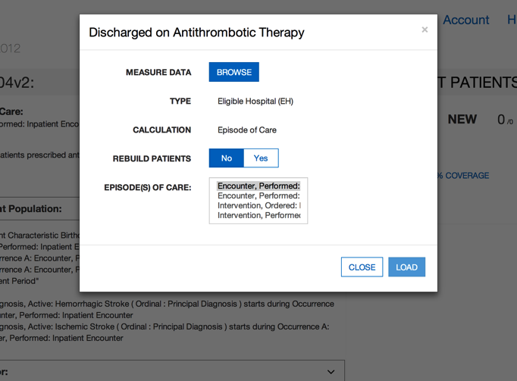

Figure . Updating Measure Dialog

## Creating Synthetic Test Records

Once a set of measures has been loaded into the Bonnie application, users can start building test patients for the measures. To build a test patient from the Measure Dashboard (), click the “Add Patient” button (item #12 in ). This action opens the patient builder screen as shown in . For more information, reference Section , *Building a Patient Test Record.*

After the user creates synthetic test patients for measures, the Measure Dashboard will display summary calculation results of the patients associated with each measure loaded by the user (). As shown in , UI elements #s5, 6, and 7 on the Measure Dashboard provide the summary results for each measure. In the “Expected” column (item #5), the UI displays the percentage of patients associated with the measure whose calculated values meet the expectations set for the patient. The “Status” column (item #6) indicates the current state of the measure—whether it is passing, failing, or new. A measure is in the passing state if all associated patients are meeting expectations. If one or more patients are not meeting expectations, then the measure is in a failing state. Any measure is in the new state when there are no patients associated with it. Finally, the “Test Patients” column (#7) displays the number of passing patients over the total number of patients as a fraction. The measure view, as represented in in Section , shows more detailed results for a measure.

# Measure Results View

## Overview

As shown in , the Measure View page displays the detailed information, associated patients, and calculation results for a single measure. In this view, users can add new patients to a measure, update a measure, and delete a measure. To access the Measure View, click on the “Measure Title” link (item #8) on the Measure Dashboard, as shown in .

The Measure View page presents the title and description of the measure, the logic for the measure, and a measure complexity indicator. The page lists the current set of test patients associated with the measure in the column on the right-hand side of the page. This column displays the summary calculation results for the patient test deck associated with the measure along with the list of patients and the individual calculation results for each. This page also shows the results of calculation for a single patient along with an overlay of the calculation results on the measure logic.

The following UI elements appear at the top of the Measure View page (indicated by their item numbers in ):

1. Measure Title – Displays the title and description of the measure.
2. Measure Actions – Allows the user to delete or update a measure definition, activate an alternate view of the measure logic, or open the Beta Clinical Quality Language (CQL) Learning Tool.
3. Measure Complexity – Indicates the measure’s degree of complexity.
4. Measure Subpopulations or Stratifications – Allows access to different subpopulations or stratifications in the measure.
5. Measure Logic – Displays a representation of the logic for the measure.
6. Logic Highlighted With Coverage – Displays the logic for the measure, highlighting which lines of the measure are covered by the test patients.
7. Patient Actions – Allows the user to export patient records and access the Patient Bank.
8. Percent Successful – Displays the percent of patients currently meeting expectations for the measure.
9. Patients Passing Count – Displays the current number of patients meeting expectations over the total number of patients in the test deck for the measure.
10. Test Coverage – Displays the percentage of the measure logic that has evaluated to true for the patient test deck. This measure provides a method for determining how much of the logic has been tested.
11. Add Patient – Allows the addition of a new patient to the test deck for this measure.
12. Failing Patient – Displays an example of a patient that is not currently meeting expectations for the measure.
13. Passing Patient – Displays an example of a patient that is meeting expectations.
14. Patient Name – Displays the name given to the patient.
15. Patient Status – Displays PASS or FAIL to indicate if the patient is meeting expectations.
16. Expand Patient Results Button – Displays the calculation details of a patient. This display will show the expected and actual values for the patient against the measure.
17. Measure Details – Clicking this button navigates the user to the Measure Details view. This is the current view.
18. Patient Dashboard – Clicking this button navigates the user to the Patient Dashboard view. This view is explained in greater detail in Section .
19. Measure Upload History – Displays a list of each time the measure was uploaded, and whether the patients passed or failed at that point in time. This view is explained in greater detail in Section .

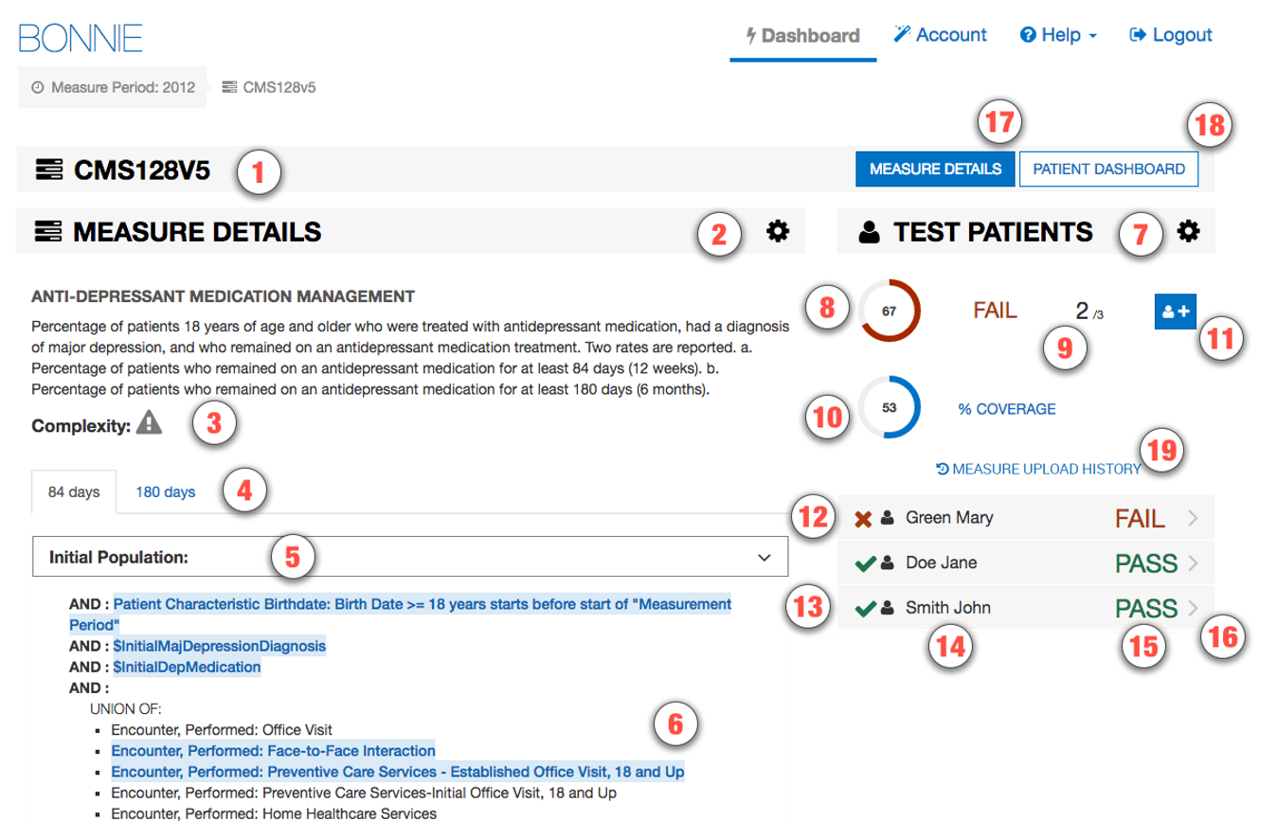

Figure . Measure View

The following UI elements (indicated by their item numbers in ) appear at the bottom of the Measure View Page:

1. Data Criteria – Displays the data elements that can be associated with a patient for a given measure. Clicking on any one of these data elements will show the list of codes associated with that data element.
2. Supplemental Data Elements – Any additional data elements that can be associated with a patient for a given measure. Generally, this includes non-medical patient demographic information.

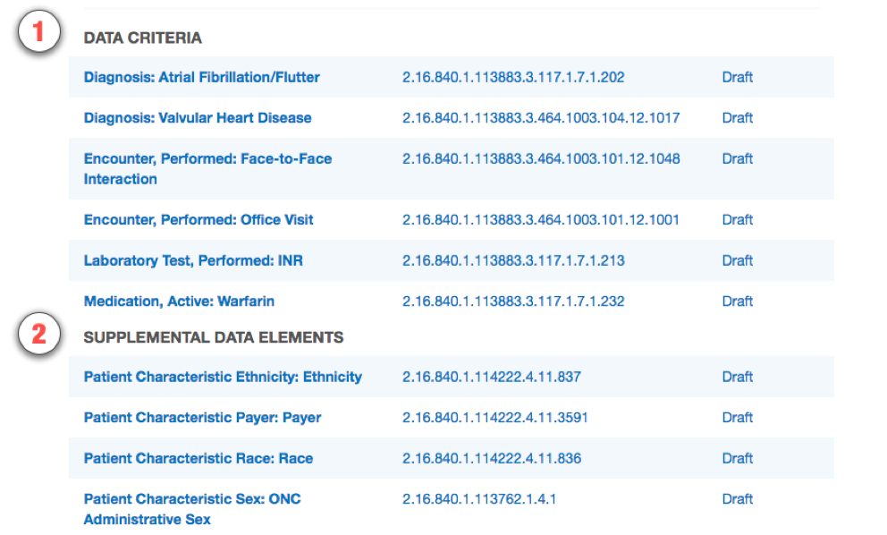

Figure . Measure Data Criteria and Supplemental Data Elements

## Measure Logic

The left-hand side of the Measure View contains the measure title, description, and a representation of the logic. The representation of the measure logic is similar to the human-readable display for the measure provided in the MAT measure exports. Some differences in the structure of the logic are a result of restructuring while parsing the measure logic from the HQMF specification. The most notable difference is that relative timings applied to logical groups are distributed down into the statements of the logical group rather than displayed at the level of the grouping.

The measure logic section can be used to verify that the measure logic was properly loaded from the HQMF without the loss of any logical conditions. The logic can also be used to evaluate the nature of the calculation of a test patient against the logic (please refer to subsection , *Calculation Results*) and to visualize the test coverage of the measure logic.

## Creating a New Test Record

To create a new test record, begin by clicking the “Add Patient” button (item #11) in the Measure View (). This action opens the Patient Builder (shown in ). Once a patient record has been created, the application returns the user to the Measure View where the user can evaluate the results of calculating the patient against the measure.

## Calculation Results

Once the user has constructed a test patient record, the user can calculate that patient against the logic of the measure in the Measure View (). High-level results are calculated automatically when the Measure View is loaded. These high-level results appear under the test patients section on the right-hand side of the Measure View. These results include the percent of patients passing (item #8), the test coverage (item #10), individual statuses for each patient (items #12–16), and the passing patient count (item #9).

In addition to these high-level results, detailed results can be displayed for an individual patient by clicking the “Expand Patient Results” button (#16). This displays a table of expected and actual results for the patient covering each population listed in the measure and shows whether that population currently meets or fails expectations.

The Expanded Results View employs the following UI elements (as indicated by their item numbers in ):

1. Failing Population – A population for which the patient fails.
2. Passing Population – A population for which the patient passes.
3. Population Column – A list of the population types.
4. Expected Value – The user-defined expected value for the population.
5. Actual Value – The calculated value for that population.
6. Edit Patient Button – Allows editing of the selected patient.
7. Clone Patient Button – Allows cloning of the selected patient.
8. Delete Patient Button – Allows deleting of the selected patient.
9. Share Patient Button – Allows sharing the selected patient to the Patient Bank. If already shared, this will display as “Unshare” and will allow the patient to be retracted from the Patient Bank.

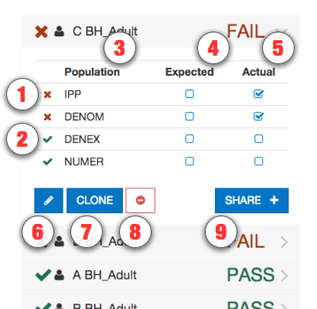

Figure . Expanded Results View

Clicking the “Expand Patient Results” button also displays the patient results calculated against each line of logic. This information is displayed in the measure logic section of the view by highlighting the lines of logic. As shown in and , a green highlight (accompanied by a check mark) indicates a passing result for the logic calculation, while a red highlight—accompanied by an “x” or an asterisk (“*”)—indicates a failing result over the applicable lines of text.

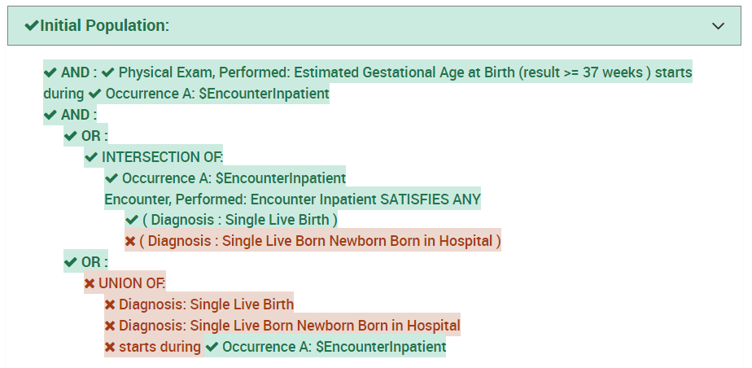

Figure . Logic Calculation Highlight – Passing Results

shows the results of a single patient calculated against the measure logic. The highlighting of the measure logic for calculation is intended to provide a clearer understanding of why a patient is calculating to a specific population. The highlighting of the logic text uses the following indications of status:

* Logic evaluated to TRUE – Green highlighting along with a checkmark icon
* Logic evaluated to FALSE – Red highlighting along with an “x” icon
* Unaligned Specific Occurrences – Red highlighting along with a bold red asterisk icon (“**\***”)

The results of the calculation in are that the patient aligns with the logic of the initial patient population (IPP). The highlighting of the logic in indicates that every AND condition evaluated to true and at least one condition from each OR evaluated to true. Based on this calculation, the IPP evaluates to true for the patient.

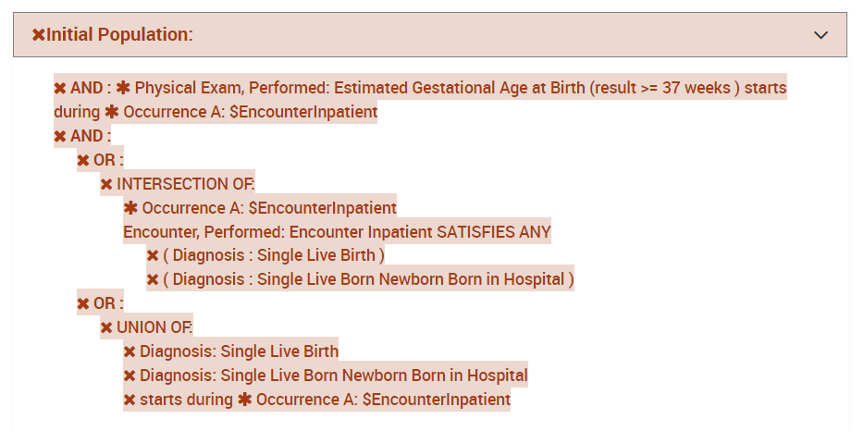

Figure . Logic Calculation Highlight – Failing Results

In , all the logical statements are highlighted in red, indicating that all statements evaluate to false. also shows unaligned specific occurrences. This state indicates that the line of logic would evaluate to true if it were not for specific occurrences. Because all logical lines related to a specific occurrence must evaluate to true for any to evaluate to true, the line does not evaluate to true. Therefore, this third indication related to specific occurrences (noted by an asterisk) helps to identify which lines referencing that occurrence may cause the calculation to evaluate to false. The results calculated in indicate that the patient is not included in the IPP.

## Editing a Test Record

The user can edit a test patient from the Measure View () by clicking the “Edit” button. The user accesses the “Edit” button for a patient (item #6 in ), accessible after expanding the patient result. Clicking the “Edit” button opens the Patient Builder (as shown in ) with the data populated for that patient. Once a patient record has been edited and saved, the application returns the user to the Measure View.

## Cloning a Test Record

The user can clone a test patient from the Measure View () by clicking the “Clone” button (item #7 in ) to the immediate right of the “Edit” button, accessible after expanding the patient result. This action opens the Patient Builder () with the data populated for the patient being cloned. The difference between editing and cloning a patient is that the clone process creates a new patient based on an existing patient, while the edit process updates the data for an existing patient. Once a patient record has been cloned, edited, and saved, the application returns the user to the Measure View.

## Deleting a Test Record

The user can delete a test patient from the Measure View () by clicking the “Delete” icon (item #8 in ) to the immediate right of the “Clone” button, accessible after expanding the patient result. Deleting a patient requires a two-step process for confirmation. Once a user deletes a patient record, the action cannot be undone. To delete a patient record, the user initially clicks the “Delete” button. A second “Delete” button is then displayed. The user must click the second “Delete” button to confirm the deletion of the patient.

## Sharing a Test Record

The user can share a test patient from the Measure View () by clicking the “Share” button (item #9 in ), accessible after expanding the patient result. Sharing a patient allows that patient to be accessible to other users through the Patient Bank. If the patient is already shared, the user may use this button to stop sharing the patient. Section provides more detail on the Patient Bank.

## Updating a Measure

The user can update a measure by clicking the “Update Measure” button, which is accessed by clicking the “Measure Actions” icon (item #2 in ). The “Update Measures” button displays the Update Measure Dialog (shown in ), which allows the user to specify a new zip package for a measure exported from the MAT. Once the new measure package has been entered, the user clicks the “Load” button, which updates the measure definition and displays the popup window shown in . The window displays exactly which patients were affected by the updated measure.

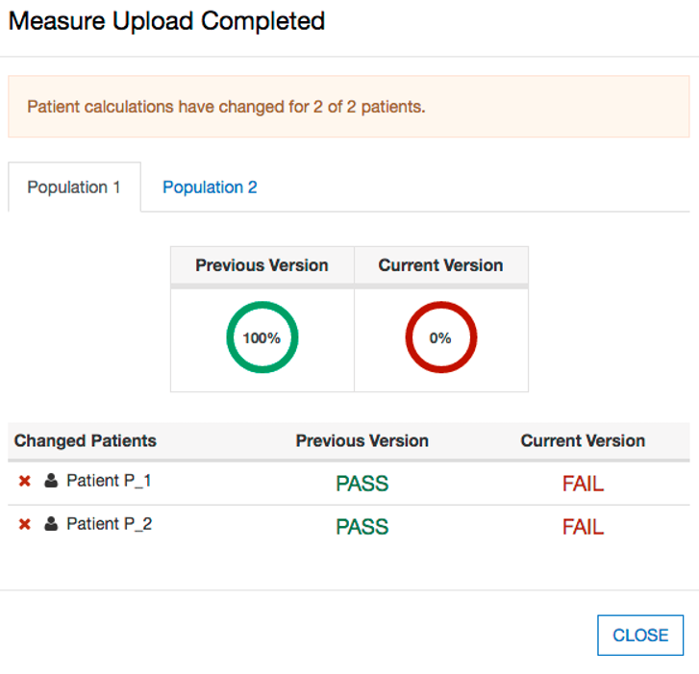

Figure . Measure Upload Summary Popup

## Deleting a Measure

The user can delete a measure from the Measure View () by clicking the “Delete” icon for a measure. To access the “Delete” icon, the user clicks the “Measure Actions” icon (item #2 in ). Once a user deletes a measure, the action cannot be undone. To delete a measure, the user initially clicks the “Delete” icon. A second “Delete” icon is then displayed. The user must click the second “Delete” icon to confirm the deletion of the measure. After the measure is deleted, the Measure Dashboard is displayed with the deleted measure no longer present.

# Building a Patient Test Record

## Overview

The Patient Builder view, as shown in , allows the addition and editing of clinical data for a synthetic test patient record. The user accesses the Patient Builder view by clicking the “Add Patient” button (item #12) on the Measure Dashboard (), or by clicking the “Add Patient,” ‘Edit,” or “Clone” buttons from the Measure View ().

The Patient Builder View employs the following UI elements (as indicated by their item numbers in ):

1. Patient Name – Allows the entry of a first and last name for the patient record.
2. Patient Characteristics – Allows the definition of characteristics data for the patient.
3. Measure Information – Shows the description for the patient’s associated measure.
4. Expectations – Allows users to set the calculation expectation for each population of the measure.
5. Actions – Allows users to save or cancel a patient record.

Compare View – Allows the user to show a comparison of how the patient was calculated after the most recent measure upload with how it is calculated currently (as the patient is being edited). See subsection .

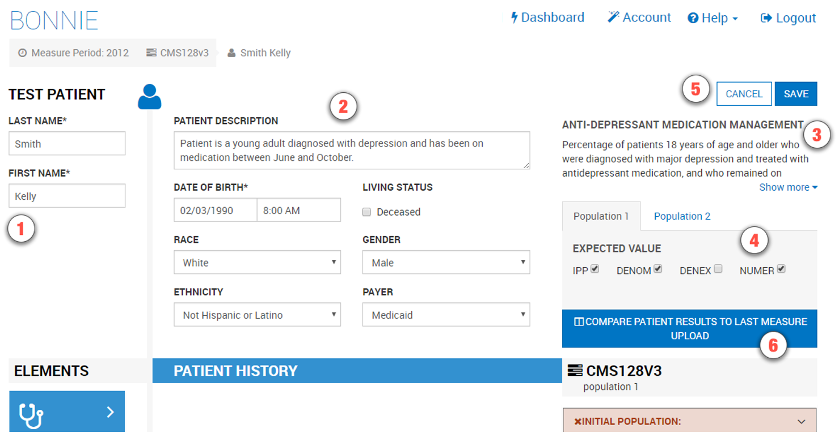

Figure . Patient Builder View

The Patient Builder view also provides fields to either add new data or edit existing data for a patient. The patient’s first and last names can be defined using the associated edit fields. Characteristics such as gender, birthdate, race, and ethnicity can be set in the characteristics section. Quality Data Model (QDM) elements can be added to the patient history section by dragging and dropping an individual element onto the patient history section.

In addition to defining the patient data, the Patient Builder view allows the user to set expectations on the patient using the “Expectations” section. Expectations represent how the user expects the patient to calculate against the measure. The “Expectations” section will be different based on the type of measure used to build the patient record. The “Expectations” section for patient-based measures provides a check box for users to select the appropriate expected populations (e.g., numerator, denominator) within which the patient will be included. The “Expectations” section for episode of care-based measures allows users to select the number of episodes of care that are expected to be included in each population using a number picker. Continuous variable measures allow users to define the expected value(s) the measure is expected to calculate for the patient.

The Patient Builder’s logic section displays the logic of the measure against which the patient test record is constructed. As data is entered, the application continuously calculates the patient against the measure logic, and the results are displayed against the measure using the logic highlighting. Subsection provides additional information about the descriptions of the logic highlighting technique based on calculation results shown in and .

## Building a Synthetic Patient

The first step in building a synthetic patient record is defining the patient name. The patient’s first and last name can be set in the “Patient Name” section (item #1 in ). The user can then add patient notes and define patient characteristics in the “Patient Characteristics” section (item #2). Characteristics for the patient include data such as birthdate, race, ethnicity, gender, payer, and living status.

After defining the patient’s name, the user defines the expectations for how the patient will behave and be calculated against the measure. The user sets the expectations for the patient in the “Expectations” section (item #4). If the user expects the patient to align with the initial patient population logic, then the user should set that expectation in item #4. Expectations are used throughout the Bonnie application to determine if a patient is passing or failing against the measure.

If the expected results for the patient align with the actual results from calculating the patient against the measure logic, the patient passes. If the expected results do not match the actual calculated results, the patient fails. This system provides the capability to build patients and set expectations for those patients based on the intent of the measure. Once the measure is calculated, the passing state indicates that the measure logic aligns with the intent, while the failing state indicates that either the measure logic does not align with the intent or the synthetic patient was constructed improperly.

Note that in , the depicted measure has a discrete expected value. Accordingly, the NUMER, DENOM, and DENEX options are shown. For continuous variable measures that rely on an aggregate calculation (e.g., a median time between ED arrival and ED departure), the OBSERV, MSRPOPL, and (optionally) MSRPOPLEX options are shown, as in .



Figure . Continuous Variable Measures Expected Populations

Although discrete measures offer only a checkbox for including patients in the NUMER population, continuous variable measures offer the ability to set a certain percentage or minute value for a given patient calculation. This value is only available if the patient is in the MSRPOPL population.

## Building the Patient History

depicts four events in the patient’s history—an encounter, a diagnosis, and two medications—based on data elements from the measure. When a QDM element is added to the patient history, it becomes an event in the patient’s history, which warrants a duration and associated fields. When an event is first created, it is given default start and end date/times and is associated with a code from each value set associated with the source QDM element. These defaults as well as additional data can be edited by expanding the event. shows an example of an expanded event from the patient history that can be edited. By clicking the expand/collapse details icon (item #3), the user can edit the details of the element.

The following UI elements are shown in :

1. Elements Section – Contains QDM elements that the user can add to the patient history.
2. QDM Element – Shows a condensed summary of a QDM element.
3. Expand/Collapse Details – Allows hiding or expanding the details of an element.
4. Start Date/Time – Allows setting the start date/time for an element.
5. End Date/Time – Allows setting the end date/time for an element. The checkbox allows specifying that the end date/time is undefined (ongoing event).
6. Codes Section – Allows adding codes to the element. Note that Bonnie will automatically find an appropriate code and add it.
7. Medication or Value Section – Allows adding values to the element (i.e., laboratory result values). This element shows details for adding a medication, allowing the user to specify amount prescribed, regimen, amount filled, and the times the prescription was filled.
8. Fields Section – Allows adding fields to the element (i.e., ordinality).
9. Negation Section – Allows indicating that the element is not done with a reason.
10. Delete Button – Allows deleting an element from the patient history.

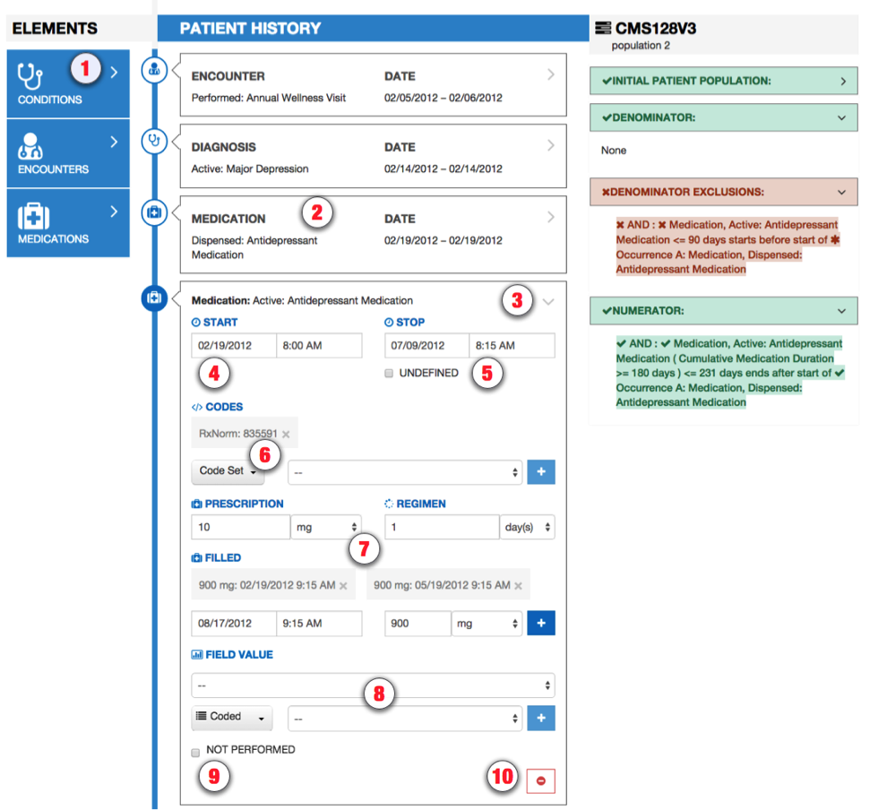

Figure . Building Patient History, including Edit Clinical Element View

After the user defines the patient characteristics, the user builds a patient history from QDM elements extracted from the measure. The available elements from the measure are organized by category and listed in the “Elements” section (item #1). The user can click a category to expand the list of available elements. Expanding this list allows the user to click and drag an individual element onto the patient history (item #2).

Several fields in the Edit Clinical Element View can be edited for an event in the patient history using the controls shown in . These fields include the start date/time of the event (items #4 and #5), codes (item #6), values (item #7), various fields (item #8), and negation rationale (item #9). The start and end date times can be set for an event by either typing into the text fields directly or by using the date/time pickers that are displayed when the field is selected. An undefined end time can be set for the event (used for active or ongoing events) by selecting the “Undefined” checkbox. Selecting the “Undefined” check box clears the end date/times, indicating that the event has not ended.

Values, fields, and negation rationale also can be set for an event. Values can be set by electing the type of the value (scalar or coded) and entering a scalar value or selecting a coded value from a drop-down listing of all the value sets associated with the measure. Fields such as ordinal, severity, discharge date/time, etc. can be added using the “Fields” section. Fields are added by selecting the type of the field (scalar, coded, or time) and entering a scalar value, selecting a value set, or entering a date.

Negation rationale can be defined for the event to indicate that the event was not done for a specific reason. Negation rationale is added by clicking the “Not Performed” checkbox in the negation section and selecting a value set representing the reason the event was not done.

Finally, events can be removed from the patient history by clicking the “Delete” icon (item #10). Deletion requires a two-step process. After initially pressing the “Delete” icon, the user is prompted to depress the “Delete” icon a second time to confirm the deletion.

### Patient History Items that Fulfill Past Items

In the course of creating the patient timeline, there may be some items that fulfill other items that occurred in the past. For example, a note or report may fulfill a specific order or referral. Users can relate these two items using the “References” section, as depicted in .

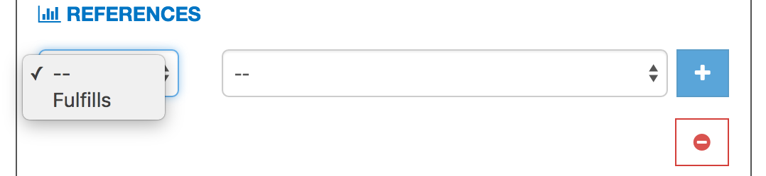

Figure . References Section of the Patient History Builder

### Representing a Cumulative Medication Duration

To represent a Cumulative Medication Duration (CMD), a medication is added to the patient history and the “Prescription,” “Regimen,” and “Filled” options are adjusted appropriately, as shown in . In this example, a prescription is specified as 10mg. This represents a single dosage of the medication. The regimen is set to 1 day, meaning that the patient takes a single dose once per day.

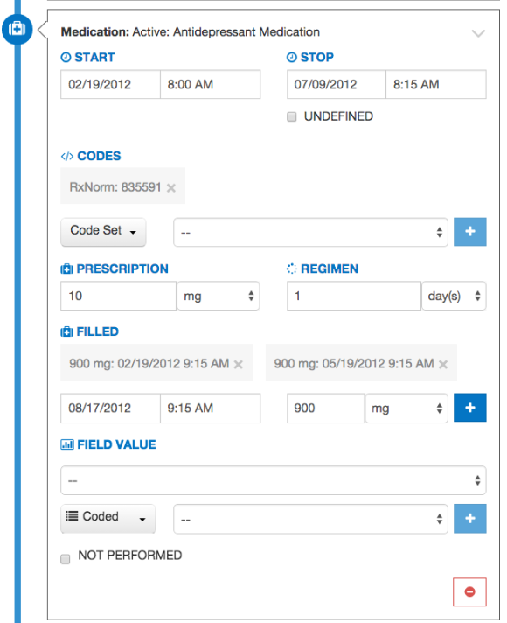

Figure . Editing a Medication

The Filled section allows simulation of this prescription being filled. It takes a date, time, and amount of medication. In this example, 900mg is entered to represent a 90-day supply of this medication (based on a 10mg daily dose). Pressing the plus-sign button (+) will add this prescription amount.

These steps lead to a CMD of 90 days. Additional prescriptions can easily be added by pressing the plus-sign button again: once more brings the total to 180 days, twice more to 270 days, and so on.

## Incremental Calculation

The final section of the Patient Builder View is the logic section. This section displays a representation of the logic for the measure against which the patient is constructed. The logic can be a reference to help describe the details of the data that should be added in building the synthetic patient.

The logic section continuously displays the results of calculating the patient against the measure by means of the logic highlighting described in and . Any modification made to a patient triggers a recalculation of the patient against the measure, which updates the results of the calculation displayed by the logic highlighting. Therefore, while the user constructs the patient record, the user can inspect the behavior of the logic relative to the patient.

When the user has completed constructing a synthetic patient, the user clicks the “Save” button in the Patient Builder View. This action adds the patient to the test deck for the measure and returns the user to the Measure View. After the user creates the first patient, additional patients can be created from scratch or cloned from existing patients to extend the coverage of the test deck against the measure.

## Outdated Code Sets

As value sets are modified over time, some previously built patients may contain codes that no longer exist in a given value set. To help with troubleshooting these occurrences, Bonnie will display a warning message at the top of the patient record page as shown in .

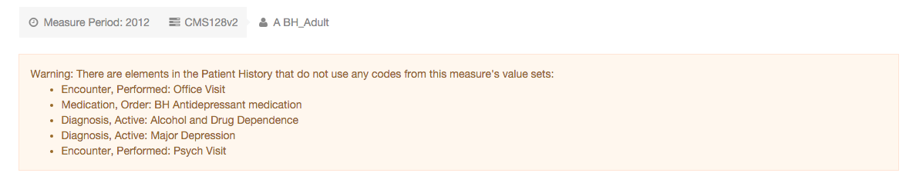

Figure . Error Message for Outdated Patient Codes

# Measure History

## Overview

As measures are updated each year, the logic within each measure changes slightly. An example could be a Diagnosis occurring *before the end of the measure period* versus a Diagnosis *overlapping the measure period*. These changes could impact whether a patient is passing or failing. A patient might have passed on a previous version of a measure, but is now failing with the updated logic. The Measure History allows you to view changes that have occurred to the patients over time. It also displays the exact logic changes between two versions of a measure.

Item #19 in the Measure View () is a button that opens the following Measure Upload History View as depicted in Figure 22.

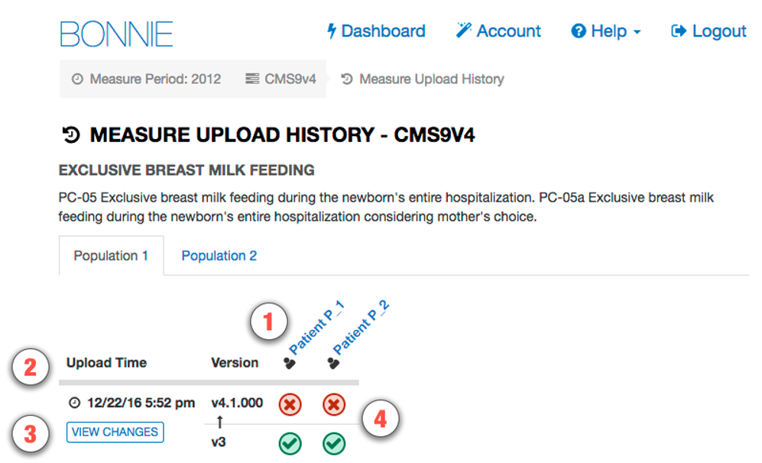

Figure . Measure Upload History View

1. List of Patients – Displays the list of patients that have existed during at least one measure upload. Clicking the Patient Name changes the page to the Patient Builder ().
2. Measure Title – Displays the version of the Measure, as well as the date and time of its upload.
3. View Changes – Displays the exact changes to the measure logic that occurred (see ).
4. Before/After Status – Displays the patient’s statuses before and after the measure upload. Clicking the icons will open a Compare View.

***Note*:** Only patients that are present at the time of the upload will display in this view. If a patient is added after the most recent upload, it will not display here until the measure is updated again.

### Viewing Changes to the Logic of the Measure

Upon clicking “View Changes” in , is displayed. This view displays the exact changes in logic from one version of a measure to another. The left half of the screen is the logic from the previous version, while the right half is the new logic for the version that has been uploaded. The highlights help to show exactly which parts of the logic were changed.

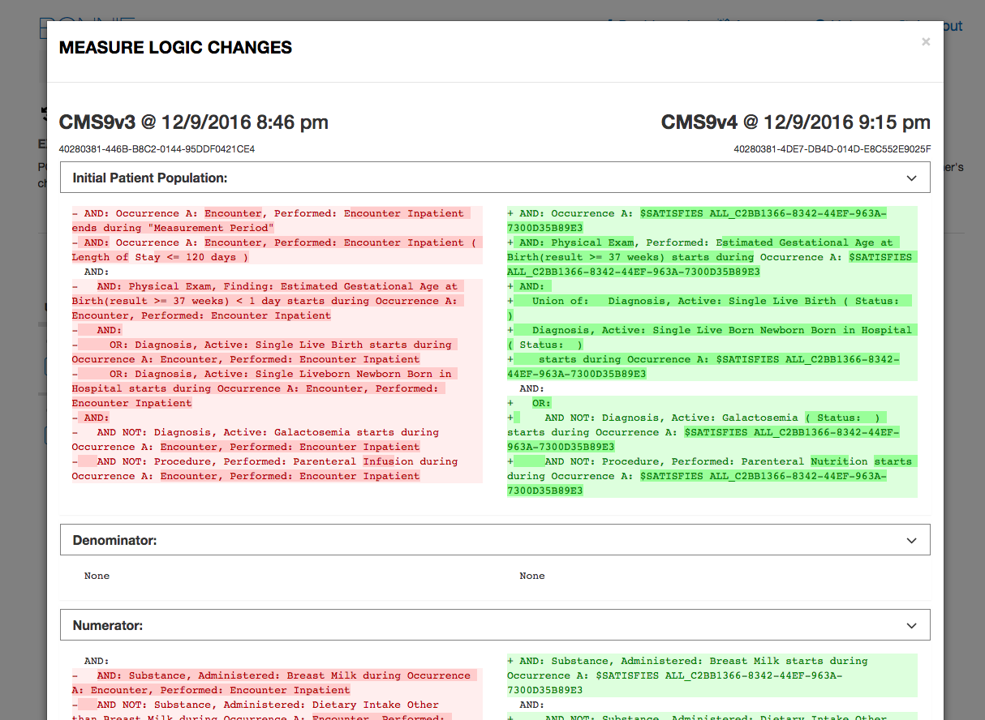

Figure . Logic Changes from an Updated Measure

## Patient Compare View

There are two ways to examine the impact of measure updates on the patients. The first is the Measure History view. Each of the status icons in are clickable links that will display the view in . In this view, the left side shows what the patient calculated before the measure was updated (uploaded). The right side shows how the patient calculated after the measure was updated (uploaded). There are no patient-related changes; only the measure logic has changed.

The second access to the Compare View is from the button within the Patient Builder (Icon #7 in ). When clicked, it displays the pop-up window in Figure 24. This Compare View shows how the patient calculated after the most recent measure upload compared with how the patient is calculating currently (as the patient is being edited). The purpose of this view is to show the user how the real-time edits change how the patient calculates against the measure compared to the patient calculation at measure upload.

The “Compare” button on the Patient Builder screen is only visible if the patient was present when the measure was last updated.

Figure 24 displays two columns. On the left we see how the patient compared against the measure logic in the previous version of the measure. On the right we see how the patient compares against the measure logic on the new version of the measure

Figure . Patient Compare View

# Patient Dashboard

## Overview

The Patient Dashboard, shown in , provides a comprehensive view of patient information and how each patient calculates. The goal of the Patient Dashboard is to support test-deck planning for measure developers. Using the Patient Dashboard, measure developers can sort and filter patients, edit multiple patients at a time using the inline editing feature, and edit data criteria on a patient using the modal pop-up editor.

The Patient Dashboard contains the following UI elements (as indicated by their item numbers in ):

1. CMS ID – Displays the CMS ID for the measure.
2. Measure Subpopulations or Stratifications – Allows access to different subpopulations or stratifications in the measure.
3. Create Patient – Allows the creation of a new patient in a Patient Builder view ().
4. Population Navigation – Allows a user to jump to a particular population to easily view the logic contained in that population.
5. Options – Contains options for the patient, including inline editing, modal editing, and deletion.
6. Result – Shows the calculation result for a particular patient.
7. Actual – Shows the actual results for each patient. If there is a discrepancy between the actual result and the expected result, this is highlighted using a red outline.
8. Expected – Shows the expected results for each patient.
9. Measure Details – Allows the user to navigate to the Measure View page.
10. Patient Dashboard – Allows the user to navigate to the Patient Dashboard page.
11. View patient table without scrolling features – Shows a 508-compliant version of the table.
12. Search – Allows a user to filter the list of patients displayed.

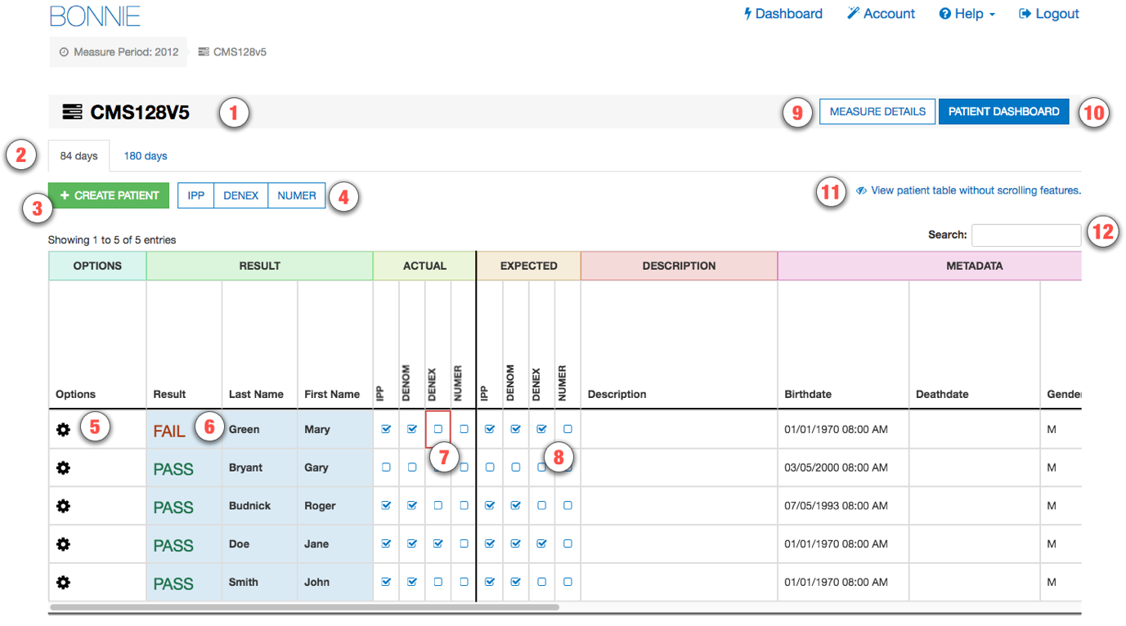

Figure . Patient Dashboard View

The Patient Dashboard’s logic sections, as shown in , contain the following UI elements:

1. Population Header – Displays the population name for that section of logic.
2. Logic – Displays first-tier logic for a particular population. This will either be a single logic statement, a variable, or a compound logic statement (a logic statement with several sub-logic statements).
3. Logic Scrollbar – Allows a user to scroll to see the complete text of a logic if it is too long.
4. Details – Allows a user to see how the patient referenced in the row calculates against the logic referenced in the column. This includes information about the sub-clauses of the referenced logic and also shows the logic included in any variables contained in the referenced logic.
5. Detail View – The details displayed in this view are described in item #4.

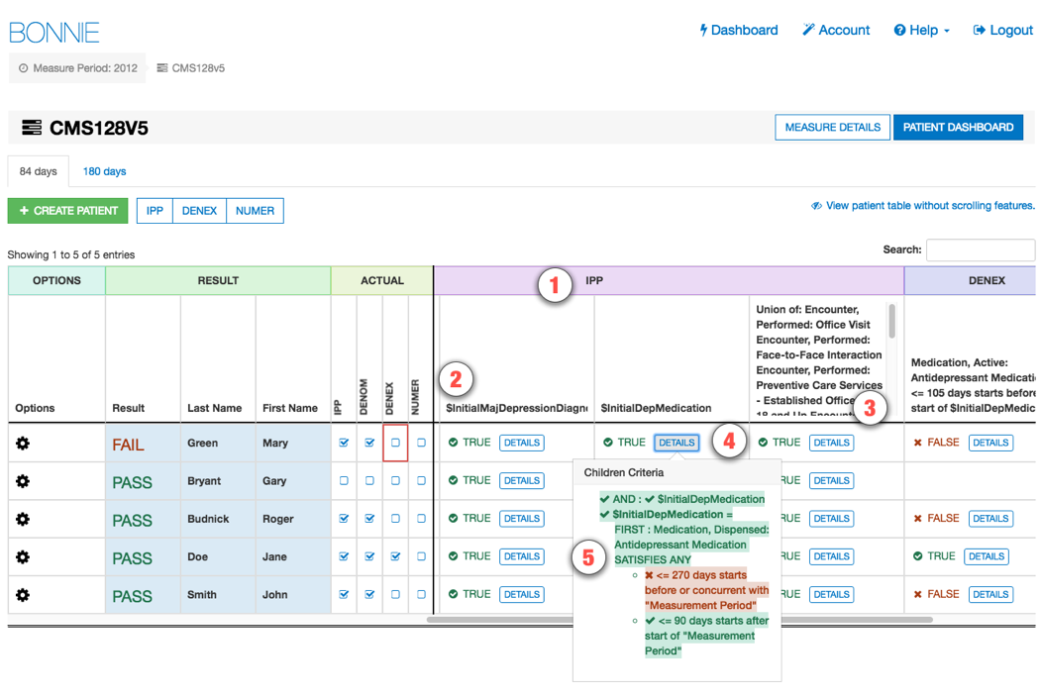

Figure . Patient Dashboard Logic

## Adding and Editing Patients

The Patient Dashboard () makes it easy to add and edit patients directly in the Patient Dashboard view. To add a new patient, click the “Create Patient” button (item #3 in ). This will display a Patient Builder modal dialog. To create a new patient, follow the steps described in Section 5.

To perform inline editing of a patient, click the gear button (item #5 in ) and then click the “EDIT” button as shown in . This action enables the Last Name, First Name, Expected Values, Description, Birthdate, Deathdate, and Gender fields for easy inline editing. When editing is complete, click the green checkmark button to save the changes or the red “x” button to cancel and not save the changes as shown in .

This figure shows the beginning of a row in the Patient Builder view. The gear button has been clicked. The following buttons are showing as a result of the gear click: "Edit," "Open," "Delete." The entries for "Last Name" and "First Name" are also shown in this view.

Figure . Patient Dashboard Options

This figure shows the beginning of a row in the Patient Builder view after the "Edit" button has been clicked. Two buttons are now shown. The first is a green button with a checkmark representing a save action. The second is a red button with an "x" representing a cancel action. The entries for "Result," "Last Name," and "First Name" are also shown.

Figure . Patient Dashboard Inline Edit

To access the full Patient Builder editing capabilities for a patient, click the “OPEN” button shown in . This opens a modal dialog that contains the Patient Builder. Follow the steps presented in Section 5 for editing in this view.

# CQL Learning Tool

## Overview

The CQL Learning Tool allows measure developers to copy and paste CQL code into Bonnie and evaluate that code against pre-existing patients. Measure Developers can thus experiment with CQL code snippets to ensure that the CQL represents the logic they expect. The CQL Learning Tool is currently in Beta and only supports QDM 4.2.

To reach the CQL Learning Tool, click the Measure Actions button in the Measure View (item #2 in Figure 10) and click “Learn CQL” as shown in . This opens a modal view with a CQL editor and a list of patients included in the measure.

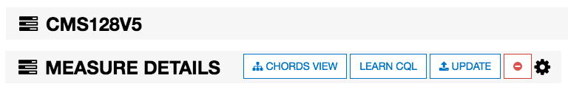

Figure . Navigating to the CQL Learning Tool

The CQL Learning Tool contains the following UI elements (as indicated by their item numbers in ):

1. Library – The library name is automatically generated from the name of the measure from which the CQL Learning Tool was launched.
2. Using QDM – The CQL Learning Tool automatically references the QDM library for use with the CQL code entered into this view.
3. Valueset – The CQL Learning Tool automatically generates the value sets that are referenced in the measure to facilitate adding CQL logic into this view.
4. Parameter Measurement Period – The CQL Learning Tool automatically creates the measurement period to match the measurement period used in Bonnie.
5. Context patient – The CQL Learning Tool automatically adds the “context patient” line to ensure the correct context for the copied-in calculation code.
6. Enter CQL Here – Any new CQL code should be copied/pasted below this line.
7. Evaluate – This button executes the CQL code against the patients included in the measure.
8. Patient List – The patients included in the measure are listed on the right-hand side. After the “Evaluate” button is clicked, evaluation results can be seen for each patient (as shown in ).

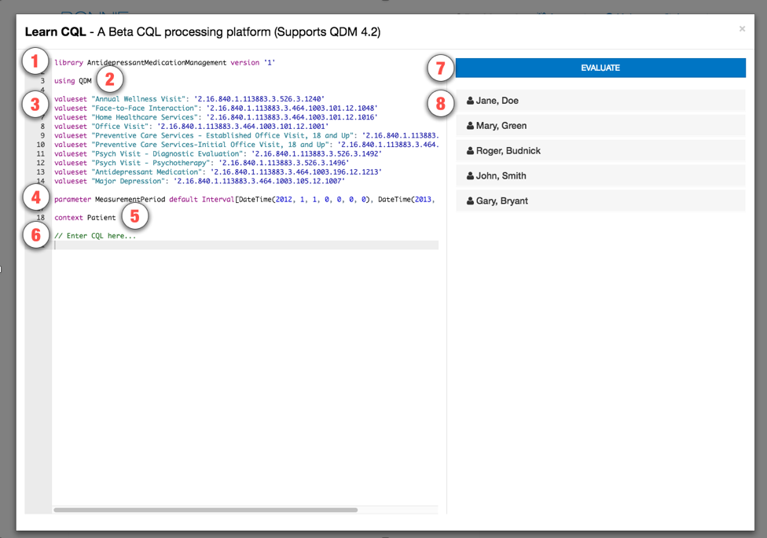

Figure . CQL Learning Tool

After CQL logic has been added to the CQL Learning Tool and the Evaluate button has been clicked, the following UI elements are displayed (as indicated by their item numbers in ):

1. CQL Logic – CQL logic that was added into the CQL Learning Tool.
2. Patient Header – After evaluation, each patient header is expandable to show how the patient evaluates against each defined logic statement.
3. Boolean Evaluation – “In Demographic” is a Boolean logic statement. Its evaluation result is shown as a green check mark to indicate that it evaluated to true, or a red “x” to indicate that it evaluated to false.
4. Set Evaluation – “Encounter” is a set calculation and returns all the data criteria associated with the patient that evaluate against the logic statement. They are displayed in this view as icons, where each icon represents a data criteria element that conformed to the measure logic. Hovering the cursor over the data criteria will display more information about those criteria.
5. Logic Error – Errors in the CQL logic are shown in the CQL editor with a red “x” symbol. Hovering the cursor over this symbol will display an error message.

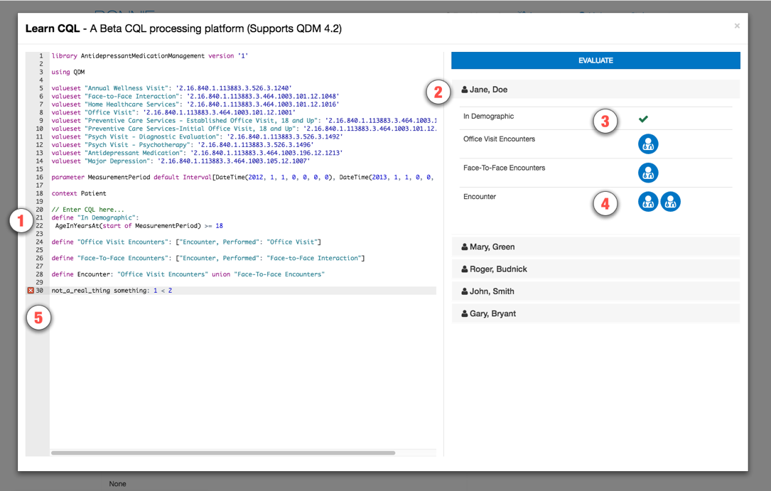

Figure . CQL Learning Tool after Evaluation

# Importing Patients from the Patient Bank

## Overview

The Patient Bank allows sharing test patients between different user accounts and between different measures. Shared patients are accessible to anyone using Bonnie. Users can select patients from the Patient Bank for export or for cloning into their own measures. Patients imported in this manner will be copies of the original patient; therefore, any edits made on the original patient will not affect a cloned patient and vice versa.

The Patient Bank shown in displays all patients who have been shared across the Bonnie application. The Patient Bank View employs the following UI elements (as indicated by their item numbers in ):

1. Measure Information – Shows the name and description of the measure.
2. Measure Patient Count – Shows the number of patients in the measure.
3. Measure Logic – Shows the coverage of logic.
4. Filters – Allows filtering on the patient results.
5. Result Count – Shows the number of shared patients.
6. Patient Indicator – Indicates whether the patient is already in your measure.
7. Patient Calculation Result – Indicates how the patient calculates against the measure.
8. Selected Patient Count – Shows the number of patients selected by the user.
9. Patient Bank Actions – Allows exporting or cloning of selected patients.

To use the Patient Bank, the user must first navigate to a measure as shown in . From the Measure View (shown in ), the user can click the “Patient Actions” button (the gear icon on the upper right, marked as item #7 in ) and then click the “Add Patient Button” icon to access the Patient Bank.

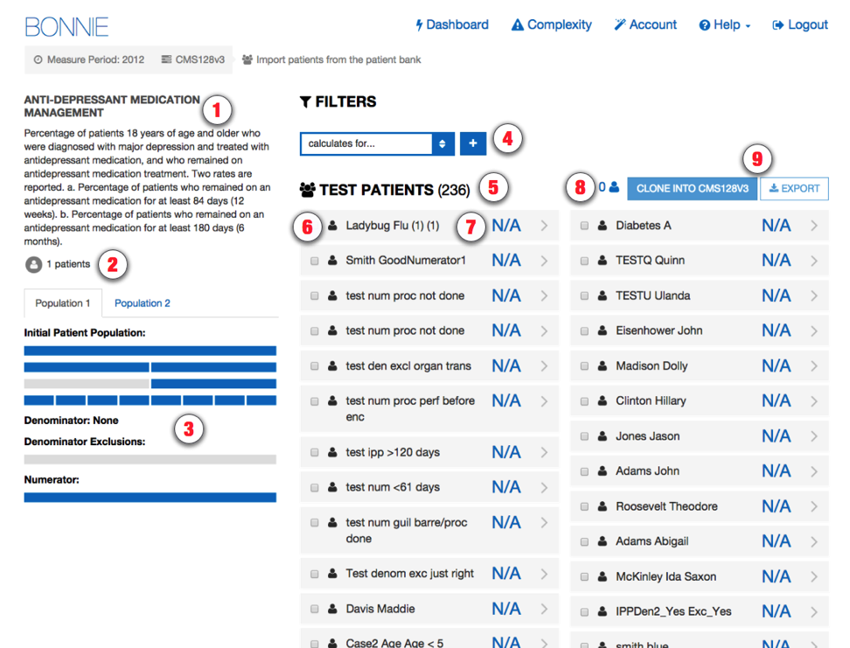

Figure . Patient Bank View

Note that the Patient Calculation Result (item #7 in Figure 32) will display “N/A” rather than pass or fail if that patient was constructed for a different measure (i.e., this patient has no expectations set for this measure).

The Patient Indicator will highlight patients already in that measure with an enclosed icon as shown by the example, “Rockland Johnny,” in , which already belongs to the user.

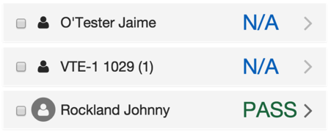

Figure . Patient Listing Example

## Filtering Patient Results

The Patient Bank includes powerful filtering capability to help the user find specific test patients. There is no limit to the number of filters; however, the results returned only contain test patients satisfying all the filters applied. It is recommended to set all desired filters before selecting test patients. The user can filter the results by population, measure, and associated user account as follows:

1. Population – Allows filtering results by whether the patient passes for a selected population for the currently displayed stratification.
2. Measure – Allows filtering results by measure. The user can enter all or part of a measure code (for example, “CMS142v2” or “142” will both work).
3. Associated User Account – Allows filtering results by user. The user can enter all or part of an email address associated with a Bonnie user account.

shows the Patient Bank filtered by whether the patient passes for the measure’s numerator for the stratification named “Population 1.” This example has one result.

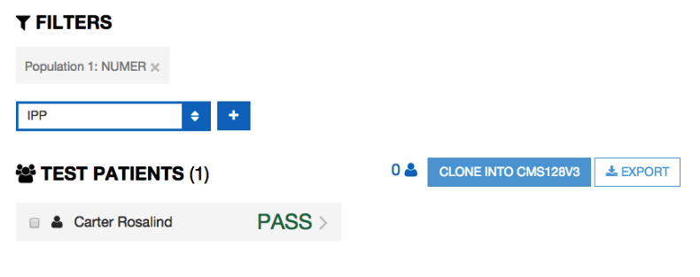

Figure . Example Filter Usage

## Using Test Patients

Each test patient result can be expanded to show further details on that patient. shows the patient summary and the calculated results for that patient.

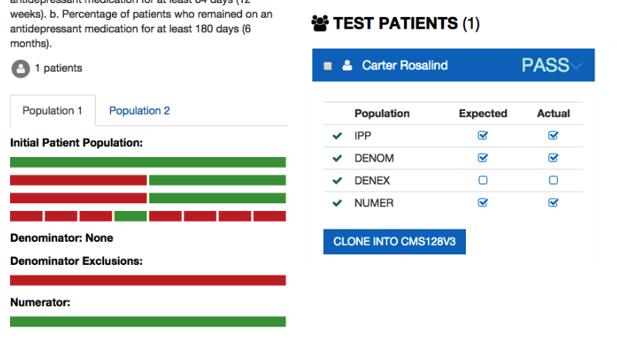

Figure . Patient Result Details

When the patient result is expanded, the measure logic view updates to show how the patient meets the data criteria. In the measure logic view shown in , the patient has data criteria that meet the green lines of logic.

The user can select one or more patients by clicking the checkbox associated with each patient as depicted in .

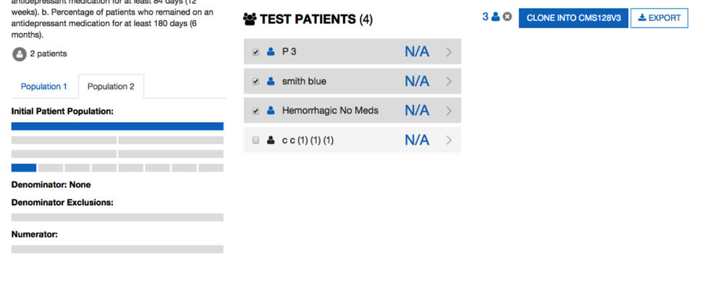

Figure . Selected Patients

Selecting patients will highlight those records with a darker background color and a blue icon. The selected patients will also be reflected in the measure logic view at the left: the blue marking indicating the sections are measure logic covered by the set of selected patients. The display shows the number of patients selected; the user can unselect all patients at once by clicking the “x” icon.

Once patients have been selected, the user can either clone these patients into the measure or export these patients in Quality Reporting Document Architecture (QRDA) and Hypertext Markup Language (HTML) formats.

# Additional Tools

Bonnie features additional tools that may be activated on a per-account basis by sending an email to the Bonnie feedback list [bonnie-feedback-list@lists.mitre.org](mailto:bonnie-feedback-list@lists.mitre.org).

## Complexity and Change Dashboard

The Complexity and Change Dashboard is available to explore how measures change between releases. Users can access activated feature from the “Complexity” link on the navigation bar as shown in . The initial page invites the user to select two sets of measures for comparison before proceeding. provides a screenshot of the complexity graph produced and shows the complexity grid available from this screen.

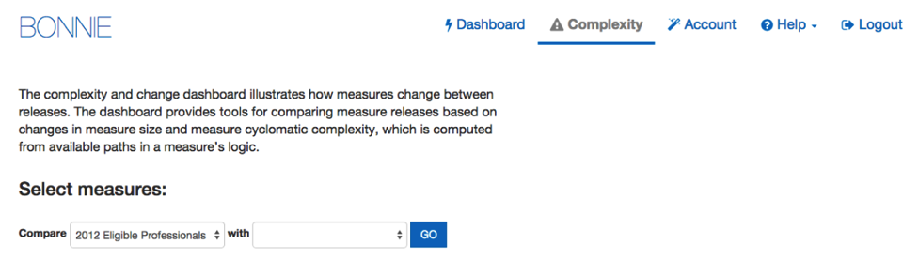

Figure . Selecting Sets of Measures to Compare

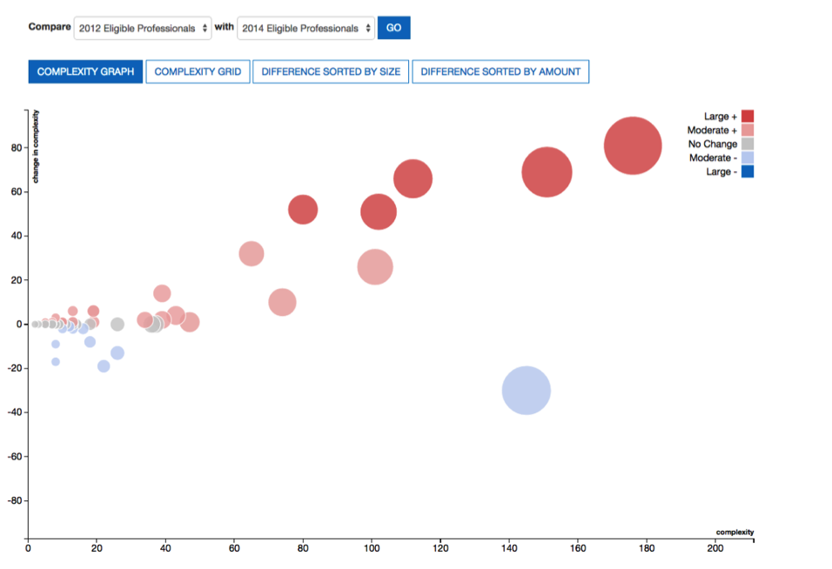

Figure . Complexity Graph

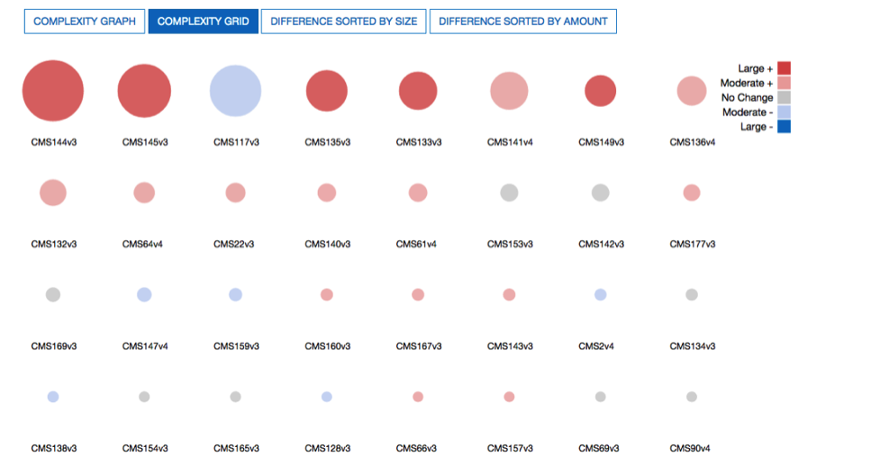

Figure . Complexity Grid

On either view, hovering the cursor over the displayed circles on either view will reveal a popup with more details on how that measure has changed. In , the measure popup shows a change from a slightly complex denominator to a simple one.

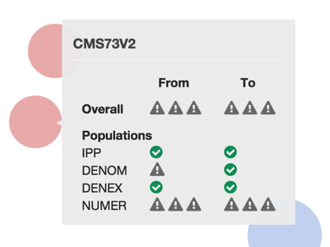

Figure . Measure Complexity Change Details

Alternatively, the changes in measures can be viewed more granularly by clicking “Difference Sorted by Size” or “Difference Sorted by Amount.” Each view illustrates a measure as a set of lines and highlights those lines that have been added, removed, or unchanged between the two sets. shows the measure difference sorted by size.

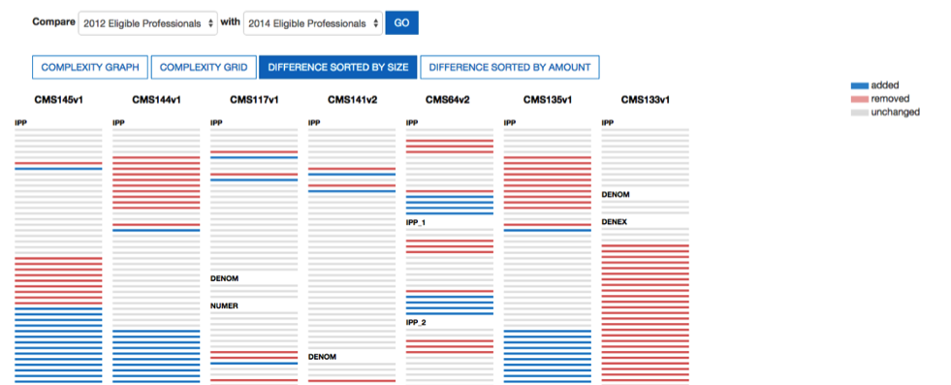

Figure . Measure Difference Sorted by Size

# Feedback and Support

An issue tracker and feedback email list are available to support the resolution of issues and to answer questions related to the Bonnie application. The Bonnie issue tracker is available on the ONC Jira system at: <http://jira.oncprojectracking.org/browse/BONNIE>

When users encounter bugs in the Bonnie application, they should use the issue tracker to report bugs, ask questions, or to request new features. To add an issue, users must create a login account in the Jira system. Once an issue has been entered, the Bonnie team will review and prioritize it. Alternatively, questions can also be addressed to the Bonnie feedback list at [bonnie-feedback-list@lists.mitre.org](mailto:bonnie-feedback-list@lists.mitre.org). The Bonnie feedback list email can be accessed using the “Contact” link in the main Bonnie navigation menu at the top of every page.

In addition to feedback provided through the issue tracker, users may join the Bonnie user group for community support. This group offers the opportunity for Bonnie users to ask and respond to questions about Bonnie and receive feedback from other community members. Bonnie developers will monitor and periodically provide input as well. To join the Bonnie user group, users may click on the “User Group” link on the splash page shown in or the User Group option in the Help menu in the application header shown in .



Figure . User Group Link on Bonnie Splash Page



Figure . User Group Link in the Application Header

# Frequently Asked Questions

Does Bonnie replace Cypress or is it an alternative to Cypress for certification?

No. Bonnie is a testing tool for measure developers to test measures as they are being authored, while Cypress is the Meaningful Use certification tool. Bonnie cannot be used for Meaningful Use certification for vendors.

Bonnie provides insight into the details of how measure logic behaves. This makes it useful to vendors, measure developers, and others in the clinical quality measure space who would like to better understand the behavior of clinical quality measures. The Bonnie testing tool uses the same measure calculation engine as the Cypress tool. Therefore, Bonnie can be used to better understand the behavior of the measures when implementing a measure prior to certification.

Can I export patient records from Bonnie?

Users can export test patients constructed using Bonnie in a human-readable (HTML) format and in the QRDA Category 1 format.

Can I load patient records into Bonnie?

Currently, Bonnie does not support loading patient records into the tool. If you would like to calculate clinical quality measures using existing patients, the popHealth tool may be a better solution.

Does Bonnie automatically generate patient records?

Currently, Bonnie does not offer the capability to automatically generate patient records based on the measure logic. The goal of Bonnie is to allow the construction of carefully considered patient scenarios. These synthetic patient records are intended to have an expected result based on the intent of the measure. Automatically generating patient records would generate patients that align with the measure logic as written, but if there were issues in the measure logic, these patients might not align with the intent of the measure.

My patient does not match the logic of the Initial Population. Why is the patient passing?

A test in Bonnie is based on assigning an expected outcome to a synthetic patient record based on the intent of the measure. A patient can be constructed with the expectation that the patient calculated is to be included in the Initial Patient Population. If the patient actually calculates to the Initial Patient Population, then the test passes. If the patient does not calculate to the Initial Patient Population, then the test fails.

There must be an exact match between the patient’s alignment and the expectation’s needs. For instance, if the expectation is set for only the Initial Patient Population, and the patient calculates to the Initial Patient Population and the Denominator, the test fails. Similarly, a patient can be constructed with the expectation that the patient does not align with any of the measure populations. In this case, if the patient does not calculate into the Initial Patient Population, the test will pass. If a patient is constructed with the expectation set of not aligning with any of the measure populations and that patient calculates into the Initial Patient Population, that test will fail.

Can I use patients that I’ve built in one measure for another measure?

Bonnie allows patient records built for one measure to be copied to another measure using the Patient Bank. The Patient Bank allows patient records to be copied between measures in the same account or in different accounts. Once a patient test record is copied from one measure to another, modifications to the patient record in one measure will not modify the copied patient record.

Where can I get help with Bonnie?

The Bonnie application has a Help menu in the header. Once you log into the application, you can use the help menu to send an email to the Bonnie feedback list to (a) ask a question directly; (b) access the Bonnie issue tracker to enter a bug, ask a question, or request a feature; and (c) access the user guide that provides step-by-step instructions on using the Bonnie tool.

What measure formats can I load into the Bonnie tool?

The Bonnie application can currently load Health Quality Measures Format (HQMF) release 1 and release 2. HQMF can be loaded directly using an HQMF xml file or it can be loaded using a Measure Authoring Tool export zip file containing an HQMF xml file. Bonnie can also load measures defined in the MAT SimpleXML format either directly using the XML file or through a MAT zip file export. Note that when loading a SimpleXML or HQMF file, you will need a National Library of Medicine (NLM) Value Set Authority Center (VSAC) account to download the value sets associated with the measure.

Do I have to be a measure developer to use the Bonnie tool?

No. Anyone can sign up for a Bonnie account using the register link on the login page.

Do I need to be a Measure Authoring Tool user to use the Bonnie tool?

No. Measures can be loaded into the Bonnie tool either by using a Measure Authoring Tool zip file export or by directly loading the measure using HQMF that has been released to the CMS website. Loading measures using a MAT zip file export will require a MAT account to download the export zip; however, if you do not have a MAT account, you can get HQMF files for the released versions of the measures from the electronic Clinical Quality Measures (eCQM) Library page on the CMS website.

Can Bonnie be used to calculate the results for a large number of patient records?

Bonnie is not designed to handle calculations for more than a few hundred patient records per measure. If you are interested in calculating clinical quality measures against a larger number of patient records, the popHealth tool may be a better solution.

Acronyms

| Term | Definition |
| --- | --- |
| CMD | Cumulative Medication Duration |
| CMS | Centers for Medicare & Medicaid Services |
| CQL | Clinical Quality Language |
| CQM | Clinical Quality Measure |
| eCQM | electronic Clinical Quality Measure |
| ED | Emergency Department |
| EH | Eligible Hospital |
| EP | Eligible Professional |
| HHS | Department of Health and Human Services |
| HQMF | Health Quality Measure Format |
| HTML | Hypertext Markup Language |
| MAT | Measure Authoring Tool |
| MU | Meaningful Use |
| NLM | National Library of Medicine |
| ONC | Office of National Coordinator for Health Information Technology |
| QDM | Quality Data Model |
| QRDA | Quality Reporting Document Architecture |
| UI | User Interface |
| VSAC | Value Set Authority Center |
| XML | Extensible Markup Language |